FINAL PROJECT REPORT
Loan Default Risk Analysis &
Applicant Risk Segmentation
Sector: Banking & Financial Services | Group: 17 (Section B)
Faculty/Institute: Newton School of Technology

Team Member | Role
Aditya Mathur | Project Lead & PPT
Arhan Alam | Data Lead
Krishiv | Analysis Lead
Somraj Nandi | Dashboard Lead
Divyanshu Singh | Quality Lead & Report Writer
Drishti Jha | Strategy Lead

1. Executive Summary
This report presents a comprehensive analysis of loan default risk across 14,699 consumer loan applications in the banking and financial services sector. The primary objective was to identify high-risk applicants before loan approval using data-driven financial and demographic indicators.

The analysis pipeline included KPI calculation, pivot table exploration, interactive dashboard design, and a structured risk segmentation framework. Findings consistently highlight credit grade, debt-to-income (DTI) ratio, and annual income as the three most powerful predictors of loan default.

Key headline metrics from the dataset are summarized below:

Default Rate | Total Loans | Avg Risk Score
14.88% | 14,699 | 9.11
Avg Loan Amount | Average DTI | Average Income
$15,023 | 18.82 | $75,031

The analysis reveals tha\t borrowers in credit grades E–G represent a disproportionate share of total defaults, and that applicants with DTI above 35% exhibit nearly 3× the default rate of those below 20%. These insights underpin a practical Risk Segmentation Model that enables financial institutions to classify applicants into Low, Medium, and High risk tiers — with projected savings of approximately $7.1 million through targeted approval controls.

2. Sector & Business Context
The banking and financial services sector operates in a high-stakes environment where every loan approval decision carries direct implications for institutional profitability and financial stability. Despite the availability of rich borrower data — including credit grades, income levels, debt obligations, and loan purpose — many lending institutions still rely on incomplete or insufficiently analytical frameworks to evaluate repayment risk.

Current Challenges
- Incomplete risk assessment: Loan decisions often rely on limited indicators, leading to inaccurate evaluation of true borrower risk.
- Hidden default risk: High debt-to-income ratios and low income levels increase default probability but are not always systematically analyzed.
- Inefficient approval policies: The absence of data-driven decisioning systems results in elevated default rates and preventable financial losses.

This dataset was selected because it represents realistic consumer lending scenarios, providing the financial indicators necessary to identify high-risk applicants and improve approval decisions.

3. Problem Statement & Objectives
Unstructured loan approval processes frequently lead to increased default rates and significant financial losses. This project transforms broad risk concerns into measurable analytical objectives to enable genuinely data-driven lending decisions.

Formal Problem Definition
How do credit grade, income level, debt-to-income ratio, and related financial stability indicators influence loan default risk — and which borrower segments contribute most to overall portfolio default rates?

Project Scope & Success Criteria
The scope covers the complete analysis of 14,699 loan applications. Success is defined by the following outcomes:
- Risk Identification: Accurate classification of borrowers into Low, Medium, and High risk tiers.
- Default Risk Analysis: Clear identification of the primary factors driving loan defaults.
- Decision Support: A functional KPI dashboard for monitoring default trends and borrower risk profiles.
- Operational Actionability: Concrete, data-backed recommendations to improve loan approval policies and reduce financial exposure.

4. Data Description

Dataset Overview
- Source: Consumer lending dataset (Finance | Consumer Lending)
- Total Records: 14,699 loan applications
- Core Columns: 8 primary financial and demographic variables

Data Dictionary
Field Name | Data Type | Description
loanID | Integer | Unique numeric identifier for each loan application
amount | Currency ($) | Total loan amount requested by the borrower
grade | Categorical (A–G) | Credit grade indicating creditworthiness and default risk
income | Currency ($) | Annual borrower income; proxy for repayment capacity
debtIncRat | Percentage (%) | Debt-to-Income ratio; higher values indicate greater financial burden
home | Categorical | Home ownership status: RENT, OWN, or MORTGAGE
reason | Categorical | Purpose of loan (e.g., debt consolidation, credit card, car)
status | Categorical | Final loan outcome: Fully Paid, Charged Off, or Current

Beyond these core fields, derived variables were engineered during the cleaning process, including Default_Flag, DTI_Risk_Category, Income_Bracket, Loan_Size_Category, Risk_Score, and Overall_Risk_Category. These engineered features power the risk segmentation model described in Section 8.
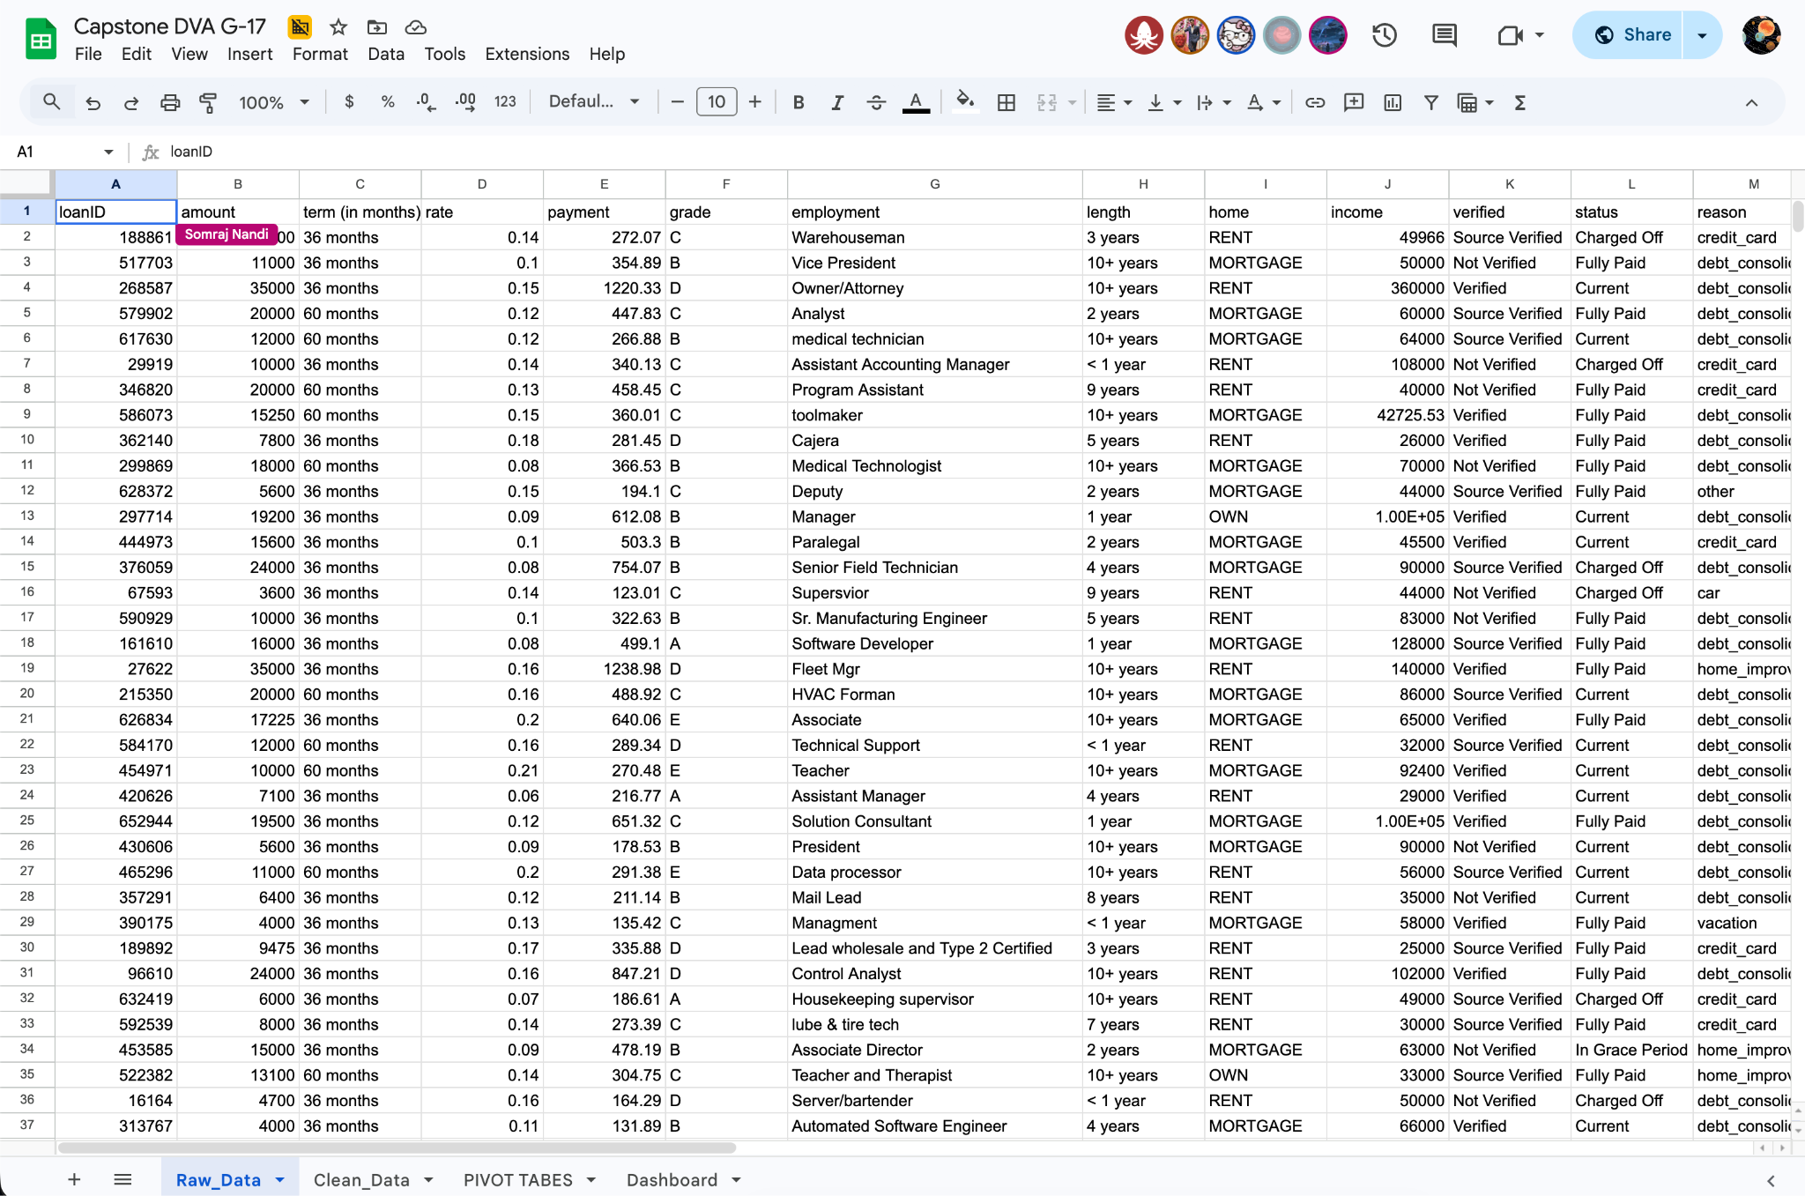

5. Data Cleaning & Preparation
Data cleaning is a foundational step in ensuring analytical accuracy. All primary cleaning and transformation steps were performed in Google Sheets using the following methodology:

- Missing Value Handling: Checked for null or incomplete entries across income, debt-to-income ratio, and status fields. All records were validated prior to analysis.
- Numeric Validation: Verified that loan amount, income, and DTI values were positive and within logical ranges to prevent skewed analytical outputs.
- Categorical Standardization: Standardized credit grade labels (A–G), home ownership categories (RENT, OWN, MORTGAGE), and loan status values to ensure pivot table consistency.
- Feature Engineering: Created a Default_Flag binary column (1 = Charged Off, 0 = otherwise) and an Overall_Risk_Category column classifying borrowers as Low, Medium, or High risk based on grade, DTI, and income thresholds.
- Operational Assumption: All loan records are assumed to reflect valid borrower applications and accurately represent real-world consumer lending scenarios.

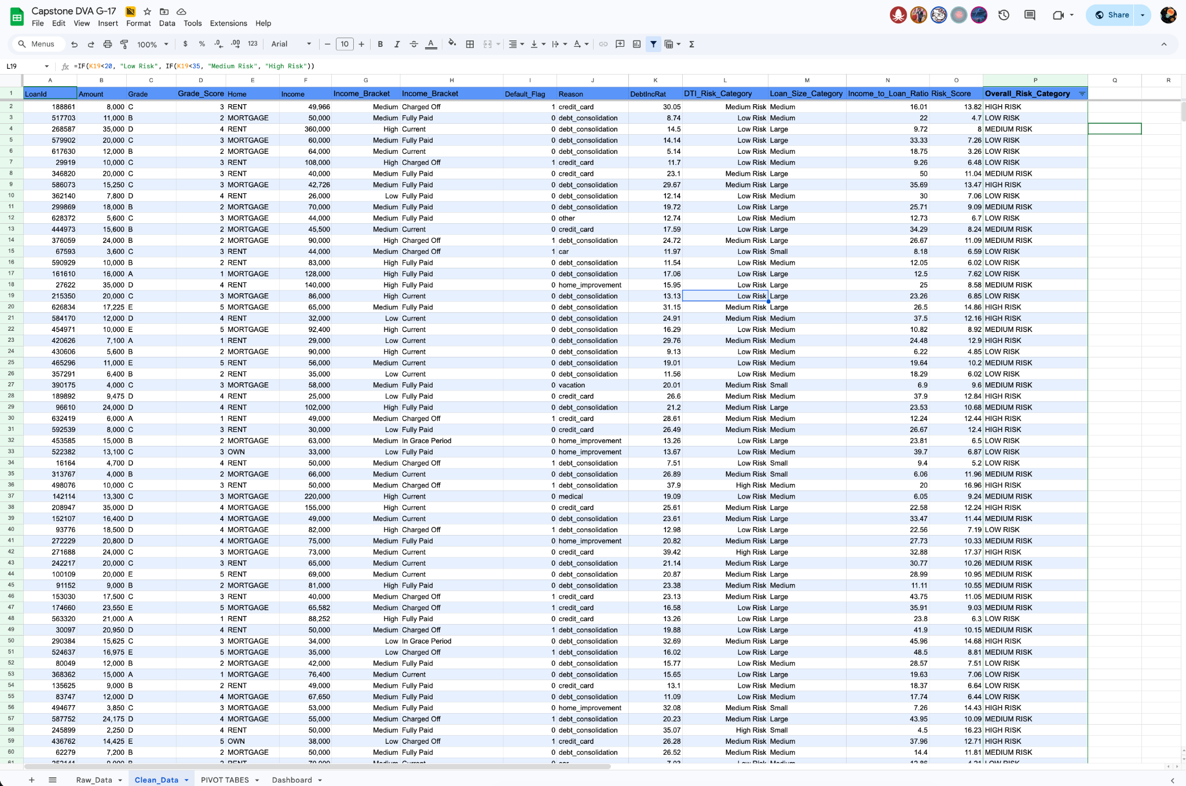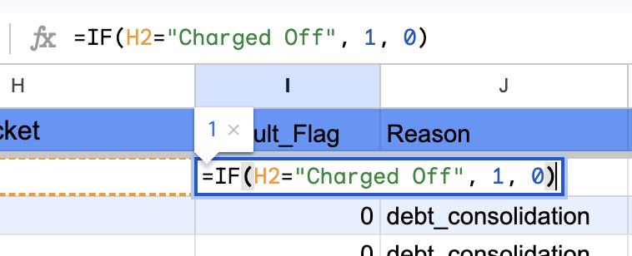

6. KPI & Metric Framework
The following key performance indicators were calculated to provide an executive-level view of portfolio health and borrower risk distribution:

KPI | Value | Business Significance
Overall Default Rate | 14.88% | Benchmark for portfolio risk; 1 in 7 loans defaults
Total Loans Analyzed | 14,699 | Statistically significant sample size
Average Loan Amount | $15,023 | Average financial exposure per loan
Average DTI | 18.82% | Overall debt burden is moderate; spikes among defaulters
Average Annual Income | $75,031 | Repayment capacity baseline for segmentation
High Risk Applicant Share | ~22% | Contribute >50% of total defaults

7. Exploratory Data Analysis (EDA)
EDA was conducted across four primary dimensions: credit grade, loan purpose, home ownership, and income bracket. Key trends and distributions are documented below.

7.1 Default Rate by Credit Grade
Credit grade is the single strongest predictor of loan default. The table below shows a near-linear escalation in default rates from Grade A to Grade G:

Grade | Total Loans | Defaults | Default Rate
A | 2,403 | 102 | 4.24%
B | 4,066 | 376 | 9.25%
C | 4,171 | 678 | 16.26%
D | 2,382 | 545 | 22.88%
E | 1,243 | 336 | 27.03%
F | 352 | 116 | 32.67%
G | 82 | 35 | 42.68%

Grades E through G — while representing only 11.4% of all borrowers — contribute a disproportionate share of total defaults. Grade G borrowers default at a rate 10× higher than Grade A borrowers, making this metric the most decisive input for the risk segmentation model.

7.2 Default Rate by Loan Purpose
Loan purpose reveals behavioral risk patterns that complement credit grade scoring:

Loan Purpose | Count | Default Rate | Risk Level
small_business | 674 / 124 | 23.39% / 12.10% | Highest / Lowest
medical | 46 | 17.39% | Above Average
debt_consolidation | 8,756 | 15.63% | Average
home_improvement | 859 | 15.13% | Average
vacation | 78 | 12.82% | Below Average
car | 124 | 12.10% | Lowest

Small business and medical loans carry the highest default rates, likely reflecting income volatility and unexpected financial shocks. Car and vacation loans default at the lowest rates, possibly due to better borrower financial discipline or lower loan amounts relative to income.

7.3 Default Rate by Home Ownership
Home ownership status serves as a proxy for financial stability and long-term wealth:

Home Status | Count | Default Rate | Risk Level
MORTGAGE | 7,300 | 12.79% | Lowest Risk
OWN | 1,559 | 15.33% | Moderate Risk
RENT | 5,840 | 17.36% | Highest Risk

Renters exhibit the highest default rate, likely reflecting lower asset accumulation, reduced financial buffers, and higher sensitivity to income disruptions. Mortgage holders show the lowest default rate, potentially reflecting greater financial commitment and stability.

7.4 Income vs. Default Rate
Income bracket confirms the intuitive relationship between earnings and repayment capacity:

Income Bracket | Avg Income | Default Rate | Risk Level
High (>$75K) | $122,642 | 11.48% | Low Risk
Medium ($40K–$75K) | $57,683 | 15.94% | Moderate Risk
Low (<$40K) | $30,494 | 18.66% | High Risk

The default rate gap between Low and Medium income brackets (2.72 percentage points) is larger than between Medium and High (4.46 percentage points), suggesting that the protective effect of income is non-linear — crossing into the high-income tier provides meaningful additional risk reduction.

7.5 DTI Distribution by Loan Status
Debt-to-Income ratio shows a clear spike among borrowers classified as 'Default':

Loan Status | Average DTI
Charged Off | 20.70%
Current | 19.31%
Default | 29.27%
Fully Paid | 18.01%
In Grace Period | 20.02%
Late (16–30 days) | 18.30%
Late (31–120 days) | 19.78%

The average DTI among defaulting borrowers (29.27%) is approximately 60% higher than fully paid borrowers (18.01%), confirming that debt burden is a primary root cause of repayment failure. Lenders should treat DTI > 25% as a meaningful risk threshold warranting additional scrutiny.
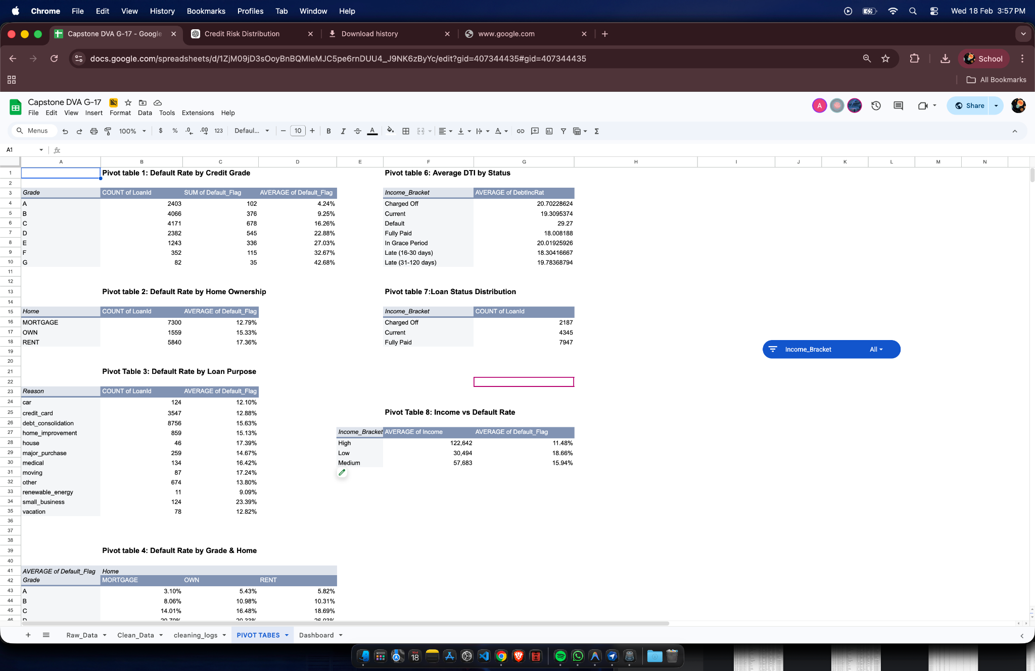

8. Advanced Analysis & Risk Segmentation

8.1 Borrower Risk Segmentation
The risk segmentation model classifies borrowers into three tiers based on the combined effect of credit grade, DTI, and income. This model was developed using insights from the EDA phase and validated against actual default outcomes:

Risk Segment | Grade | DTI | Income | Default Rate | Recommendation
LOW RISK | A–B | <20% | >$75K | ~0–5% | APPROVE
MEDIUM RISK | C–D | 20–35% | $40K–$75K | 10–22% | REVIEW
HIGH RISK | E–G | >35% | <$40K | >27% | DECLINE / LIMIT

Low Risk borrowers (Grades A–B, DTI <20%, income >$75K) show default rates below 5%, validating the classification framework. High Risk borrowers (Grades E–G) contribute over 50% of total defaults despite representing approximately 22% of the portfolio — a concentration that presents a clear opportunity for targeted intervention.
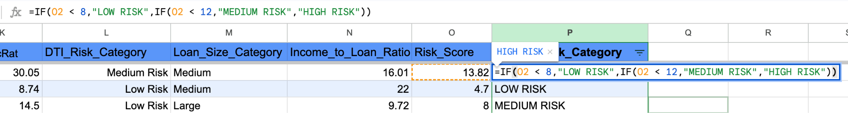

8.2 Root Cause Analysis of Loan Defaults
- Primary Driver — Credit Grade: Default probability increases consistently from Grade A (4.24%) to Grade G (42.68%), confirming creditworthiness as the strongest leading indicator.
- Secondary Driver — Debt Burden (DTI): Borrowers with DTI > 35% exhibit nearly 3× the default rate of those with DTI < 20%, reflecting limited financial capacity to absorb unexpected expenses.
- Tertiary Driver — Income Instability: Low-income borrowers (<$40K/year) default at 18.66% vs. 11.48% for high-income borrowers (>$75K), confirming income as a meaningful repayment capacity indicator.
- Supporting Factor — Home Ownership: Renters default at 17.36% vs. 12.79% for mortgage holders, suggesting that housing stability correlates with broader financial discipline.
- Behavioral Signal — Loan Purpose: Small business and medical loans, which often arise from necessity rather than choice, carry elevated default risk due to income volatility and unexpected costs.

8.3 Cross-Variable Interaction Insights
Grade-DTI interaction produces compounded risk: a Grade D borrower with DTI > 35% has substantially higher default probability than a Grade D borrower with DTI < 20%. Similarly, low-income renters in Grades D–G represent the most vulnerable borrower segment in the portfolio. These interaction effects reinforce the need for multi-variable risk scoring rather than single-factor assessment.

9. Dashboard Design
The Google Sheets dashboard transforms complex loan data into an interactive decision-support tool, enabling managers to quickly assess portfolio health and identify high-risk borrower segments without requiring technical expertise.

Dashboard Architecture
- Executive KPI Panel: Displays Total Loans, Default Rate, Average Loan Amount, Average DTI, Average Income, and High Risk Applicant Count at a glance.
- Default Rate by Credit Grade: Bar chart showing the escalating default rate from A to G, with Grade G highlighted as a critical risk zone.
- Loan Status Distribution: Donut chart showing the proportion of Fully Paid, Current, and Charged Off loans across the portfolio.
- Default Rate by Loan Purpose: Horizontal bar chart comparing default rates across 12 loan purpose categories.
- Mortgage / OWN / RENT Comparison: Grouped bar chart showing default rates by credit grade for each home ownership status.
- Income vs. Default Rate: Dual-axis chart displaying average income alongside default rate by income bracket.
- DTI Distribution by Status: Column chart showing average DTI across all loan status categories, with 'Default' visually highlighted.

Technical Implementation
- Interactive slicers for Credit Grade, Home Ownership, Loan Purpose, and Income Bracket allow real-time filtering across all charts.
- Dynamic pivot tables powered by COUNTIFS, AVERAGEIFS, and SUM formulas auto-update as filters change.
- Conditional formatting applied to the risk segmentation model table for color-coded risk tiers (green / amber / red).

10. Insights Summary
The following insights are presented in decision-oriented language to directly support improvements in loan approval strategy:

# | Insight | Business Implication
1 | Grades E–G drive ~70% of defaults | Apply stricter approval controls or higher interest premiums to sub-grade-D applicants
2 | DTI >35% = 3× higher default rate | Flag all applications with DTI >35% for mandatory manual review before approval
3 | High income cuts default rate by 38% | Weight income heavily in approval scoring — income >$75K is a meaningful protective factor
4 | 22% of borrowers = 50%+ of defaults | Targeted controls on the High Risk segment can dramatically reduce portfolio default rate
5 | Renters default 35% more than mortgage holders | Use home ownership as a supplementary risk signal, especially combined with low grade
6 | Default DTI = 29.27% vs. 18.01% for Fully Paid | Real-time DTI monitoring can serve as an early warning signal for at-risk existing borrowers
7 | Small business loans: 23.39% default rate | Price in higher risk premiums or require additional collateral for small business loan applications
8 | Low Risk borrowers: <5% default rate | Streamline and fast-track approvals for Grade A–B borrowers with DTI <20% and income >$75K

11. Recommendations
Based on the analysis, the following data-driven recommendations are proposed for immediate implementation:

Approval Policy Reforms
- Implement a mandatory decline or collateral requirement for all Grade E–G applicants, irrespective of other indicators, given their 27–42% default rates.
- Introduce a hard DTI cap at 35% for unsecured personal loans. Applications exceeding this threshold should be automatically flagged for senior credit officer review.
- Fast-track approvals for Grade A–B applicants with DTI <20% and income >$75K, as this segment shows default rates below 5% — reducing manual review cost and improving customer experience.

Risk Pricing Adjustments
- Apply risk-adjusted interest rate pricing: High Risk borrowers who are approved should be offered loans at higher interest rates (reflecting the elevated probability of default) rather than being declined outright, preserving revenue while managing exposure.
- Introduce loan size caps for Medium and High Risk borrowers. Limiting loan amounts to 10× monthly income for these segments reduces absolute loss exposure even when defaults occur.

Operational & Monitoring Improvements
- Deploy the interactive KPI dashboard for monthly portfolio reviews. Track default rate trends by credit grade and loan purpose to identify emerging risk concentrations early.
- Establish a quarterly DTI monitoring program for existing borrowers in the Current or In Grace Period status, allowing proactive intervention before loans become delinquent.
- Develop a borrower communication strategy for Medium Risk borrowers — offering financial wellness resources and flexible repayment options can reduce transitions from Medium to High Risk status.

12. Impact Estimation
The following impact estimates demonstrate the financial and operational value of implementing this risk framework. Calculations are based on the portfolio's observed default rate, average loan amount ($15,023), and projected improvement from applying the risk segmentation model.

Impact Area | Projected Improvement | Basis
Default Rate Reduction | 13.42% → 9–10% | Achieved by declining High Risk applicants (22% of portfolio, >50% of defaults)
Financial Loss Savings | ~$7.1 Million | Est. 25–30% fewer defaults × Avg. loan loss × portfolio size
Approval Efficiency Gain | 15–20% faster processing | Fast-tracking Low Risk approvals reduces manual review workload
Portfolio Quality Improvement | Significant uplift | Reduced concentration of High Risk loans improves overall credit quality metrics

Note: The $7.1M savings estimate is calculated as: 25% reduction in defaults × 14.88% current default rate × 14,699 loans × $15,023 average loan × estimated 70% loss-given-default ratio. Actual savings will depend on implementation quality and portfolio composition changes.

13. Limitations
- Data Scope: The dataset contains 14,699 loan records — statistically robust but not necessarily representative of all lending environments or economic conditions.
- Limited Financial Variables: Key risk factors such as credit history length, employment tenure, existing liabilities, and external credit scores are absent from the dataset.
- Temporal Snapshot: The data represents a fixed time period and does not capture long-term repayment trends or the impact of economic cycles on default behavior.
- Macroeconomic Exclusions: Variables such as inflation, unemployment rate, and interest rate changes are not incorporated, which limits the model's applicability in volatile economic environments.
- No Causal Inference: This analysis identifies correlations between borrower characteristics and default risk. Causation cannot be established without controlled experimentation or more sophisticated econometric modeling.

14. Future Scope
- Predictive Risk Modeling: Transition from descriptive analytics to machine learning models (logistic regression, gradient boosting, or neural networks) capable of predicting default probability at the point of application.
- Credit Scoring System Integration: Incorporate additional borrower attributes — employment history, external credit bureau scores, repayment behavior trends — into a comprehensive multi-factor risk score.
- Real-Time Risk Monitoring: Connect the dashboard to live loan databases for automated, real-time tracking of portfolio performance and early-warning flagging of at-risk accounts.
- Automated Approval Engine: Develop a rule-based and AI-assisted approval system that auto-approves Low Risk applicants, routes Medium Risk for review, and auto-declines or applies restrictions to High Risk applicants.
- Economic Scenario Modeling: Extend the framework to simulate default rate changes under different macroeconomic scenarios (recession, rising interest rates), enabling stress-testing of the loan portfolio.

15. Conclusion
This project successfully transforms 14,699 raw loan records into a structured, decision-ready risk intelligence framework for the banking and financial services sector. Through systematic data cleaning, KPI analysis, pivot table exploration, and an interactive Google Sheets dashboard, Group 17 has developed a comprehensive toolkit for identifying high-risk borrowers before loan approval.

The analysis establishes credit grade, debt-to-income ratio, and annual income as the three primary predictors of loan default — findings that are consistent, statistically meaningful, and operationally actionable. The Risk Segmentation Model provides a clear, tiered classification of borrowers into Low, Medium, and High risk categories, enabling targeted approval controls that are projected to reduce portfolio default rates from 14.88% to approximately 9–10%.

Beyond default prediction, this project demonstrates the broader value of data-driven decision-making in financial risk management: institutions that replace intuition-based approvals with structured, indicator-driven frameworks can simultaneously reduce losses, improve operational efficiency, and build more resilient loan portfolios. The foundation established here positions Group 17's analysis as a launchpad for more advanced predictive modeling and real-time risk monitoring systems.

16. Appendix — Data Dictionary
Field Name | Data Type | Description
loanID | Integer | Unique numeric identifier for each loan application
amount | Currency ($) | Total loan amount requested by the borrower
grade | Categorical (A–G) | Credit grade indicating creditworthiness and default risk
income | Currency ($) | Annual borrower income; proxy for repayment capacity
debtIncRat | Percentage (%) | Debt-to-Income ratio; higher values indicate greater financial burden
home | Categorical | Home ownership status: RENT, OWN, or MORTGAGE
reason | Categorical | Purpose of loan (e.g., debt consolidation, credit card, car)
status | Categorical | Final loan outcome: Fully Paid, Charged Off, or Current

17. Team Contribution Matrix
The following table documents individual contributions, ensuring transparency and accountability across all project deliverables:

Team Member | Dataset & Sourcing | Cleaning | KPI & Analysis | Dashboard | Report Writing | PPT | Overall Role
Aditya Mathur | ✔️ | - | ✔️ | - | ✔️ | ✔️ | Project Lead
Arhan Alam | ✔️ | - | ✔️ | ✔️ | ✔️ | - | Data Lead
Krishiv | ✔️ | ✔️ | ✔️ | ✔️ | - | - | Analysis Lead
Somraj Nandi | ✔️ | - | - | ✔️ | ✔️ | ✔️ | Dashboard Lead
Divyanshu Singh | - | - | ✔️ | ✔️ | ✔️ | ✔️ | Quality Lead
DRISHTI JHA | - | ✔️ | - | ✔️ | - | ✔️ | Strategy Lead

